Git Hands-On Assignment
Digital Nurture 5.0 - Week 7
Name: Akshay Thakur
Assignment 1: Git Setup and First Commit
Aim: Setup Git environment, initialize a local repository, add a file, and push to GitHub.
Steps Performed:
1. Configured Git globally with username and email.
2. Created a new directory "GitDemo" and initialized it as a Git repository.
3. Created "welcome.txt" file with content "Welcome to Git".
4. Added and committed the file locally.
5. Created a remote repository on GitHub and pushed the changes.

Commands Used:
git init
git checkout -b main
echo "Welcome to Git" > welcome.txt
git add welcome.txt
git commit -m "Add welcome.txt"
git remote add origin https://github.com/CodeArtisanAksahy/Digital-Nurture-5.0-java-FSE
git push -u origin main

Screenshot:
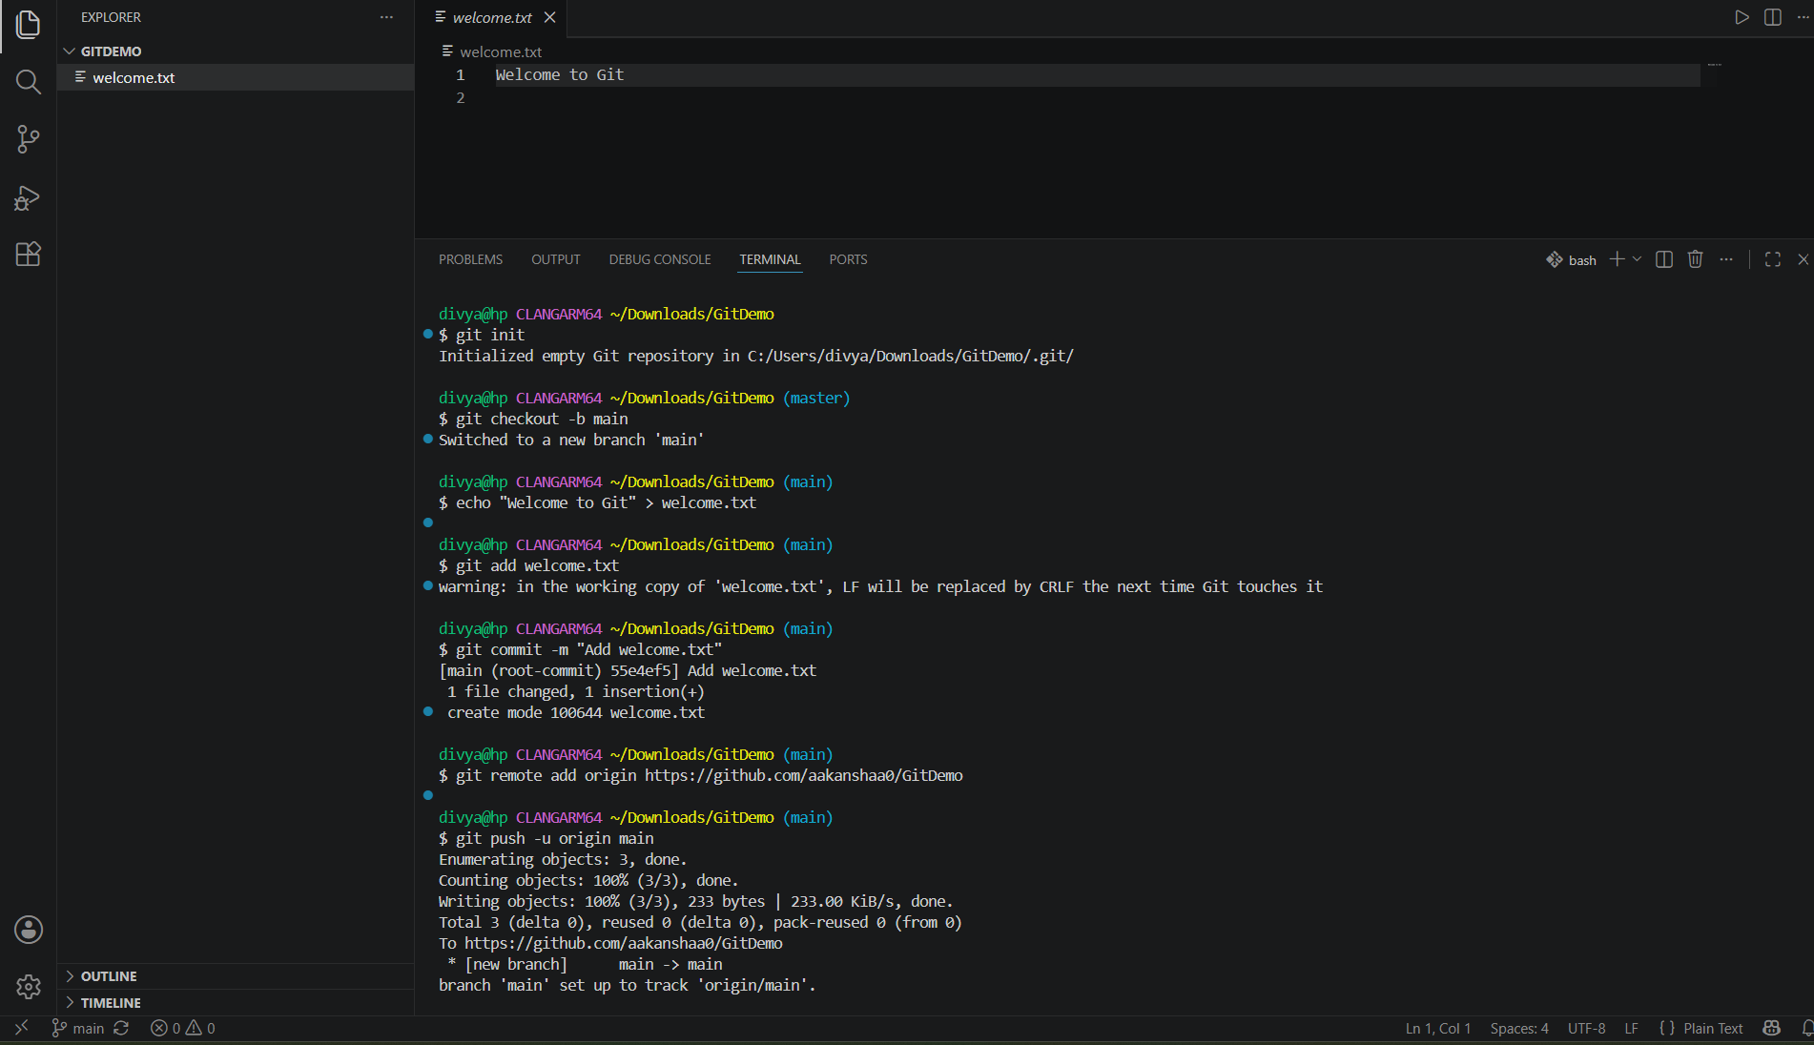
Output:
File successfully pushed to GitHub repository.

Assignment 2: Git Ignore
Aim: Ignore unwanted files (.log files and log folder) using .gitignore.
Steps Performed:
1. Created file.log and log/ folder with logfile.log inside.
2. Created .gitignore file and added "*.log" and "log/".
3. Verified that git status does not show these files.
4. Added and committed .gitignore.
Commands Used:
echo "This is a log file" > file.log
mkdir log
echo "log file inside folder" > log/logfile.log
echo "*.log" > .gitignore
echo "log/" >> .gitignore
git add .gitignore
git commit -m "Add .gitignore to ignore log files"
git push
Screenshot: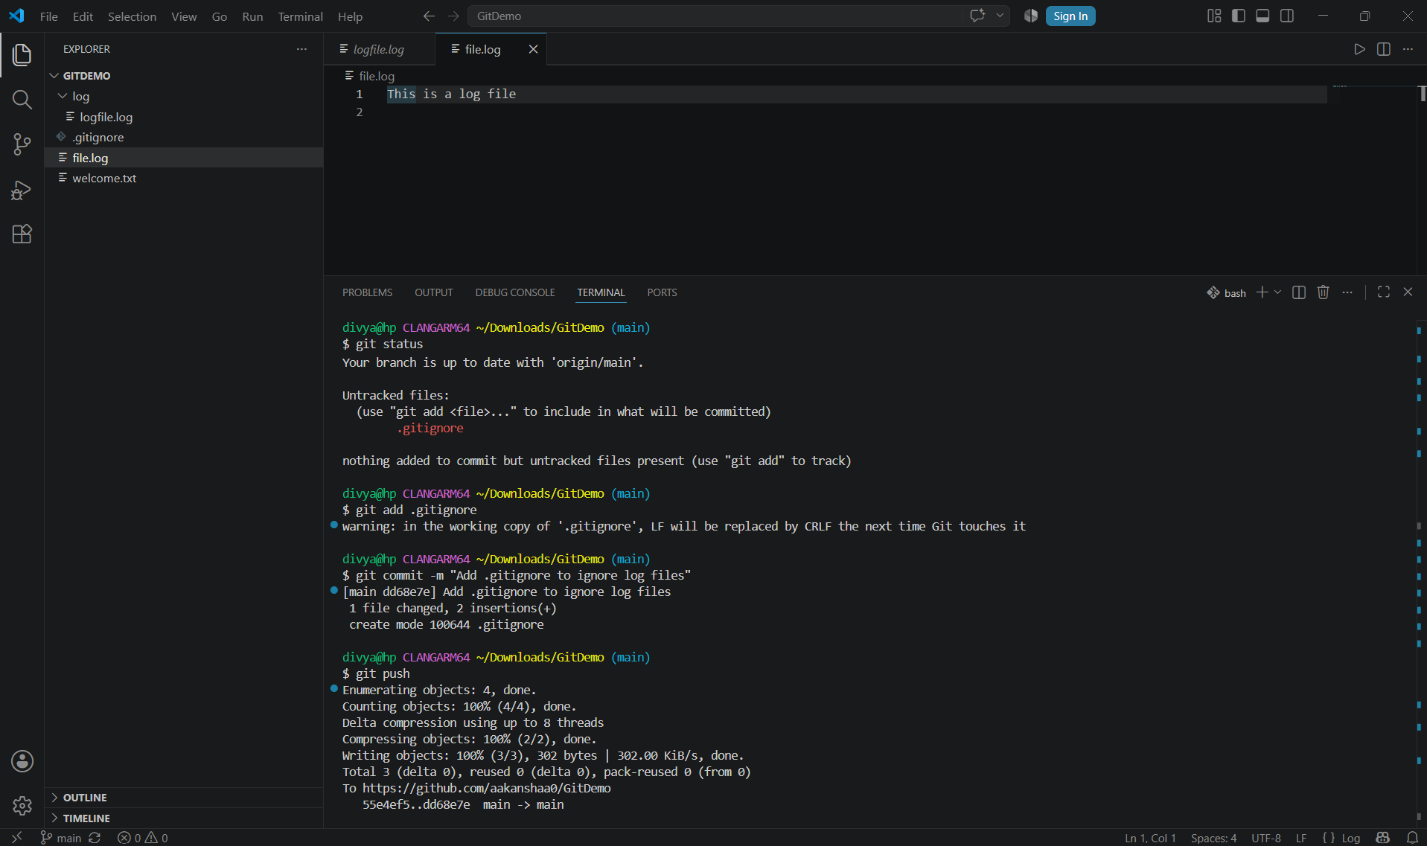
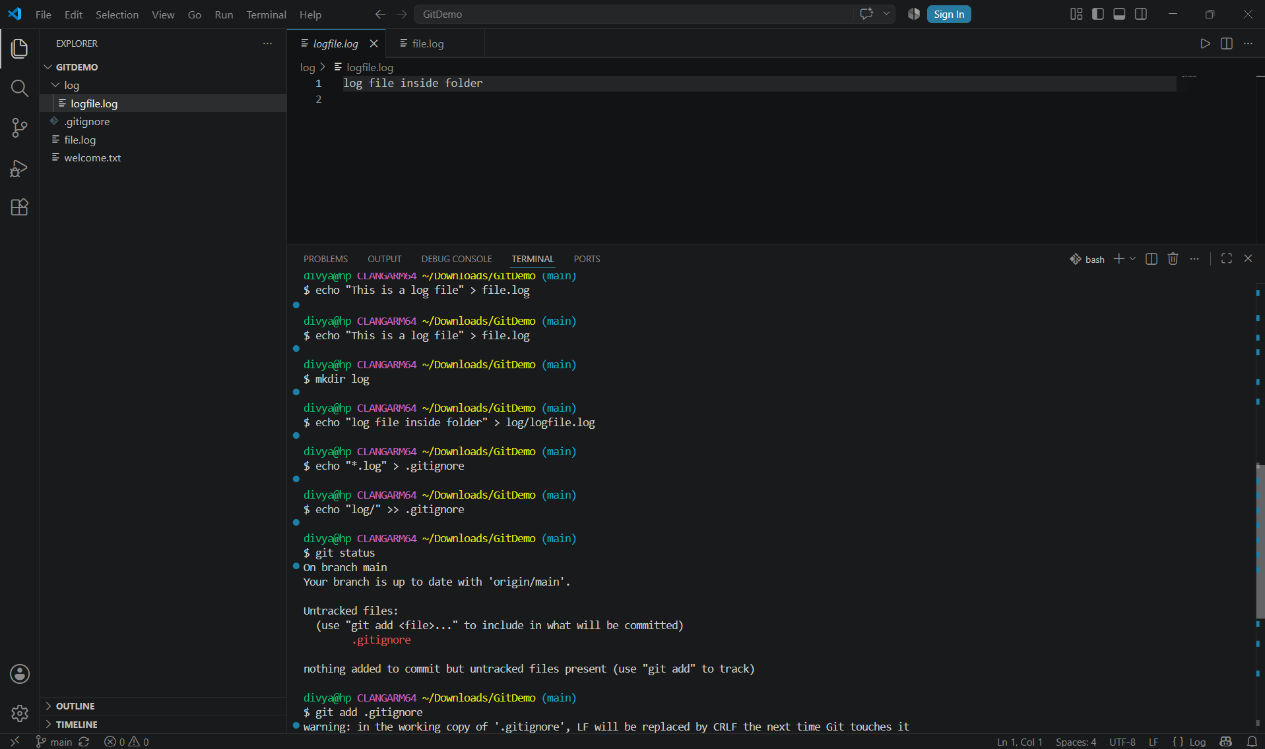
Output:
Git status shows only .gitignore, not .log files or log folder.

Assignment 3: Branching and Merging
Aim: Create a branch, add changes, and merge back to main.
Steps Performed:
1. Created and switched to branch "GitNewBranch".
2. Added branchfile.txt with content "Branch content".
3. Committed the changes in branch.
4. Switched to main and merged the branch.
5. Deleted the branch after merging.
Commands Used:
git branch GitNewBranch
git checkout GitNewBranch
echo "Branch content" > branchfile.txt
git add branchfile.txt
git commit -m "Add branchfile.txt from GitNewBranch"
git checkout main
git merge GitNewBranch
git branch -d GitNewBranch
Screenshot:
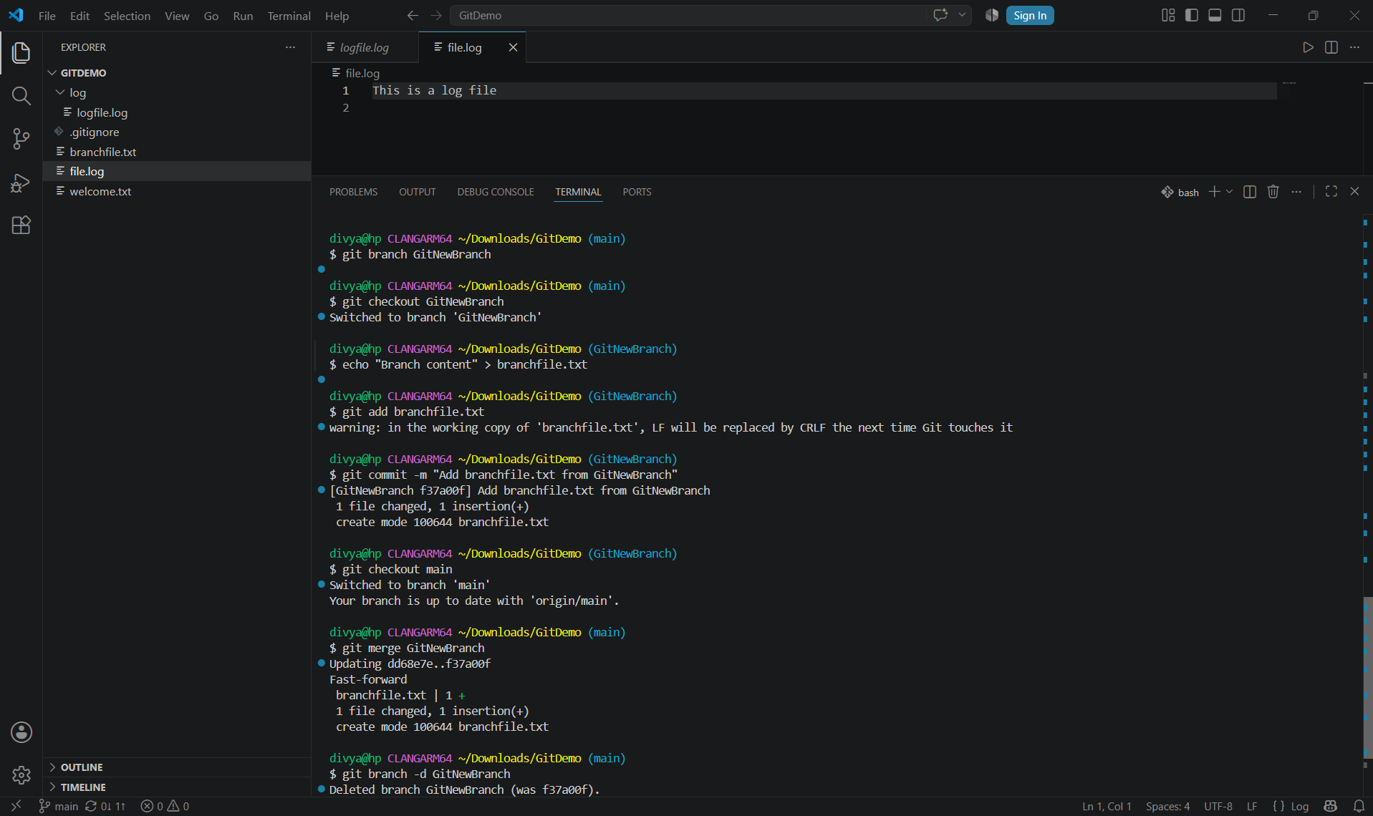
Output:
Branch successfully merged and deleted.

Assignment 4: Conflict Resolution
Aim: Create a merge conflict and resolve it.
Steps Performed:
1. Created branch "GitWork".
2. Added hello.xml with content "<hello>from branch</hello>".
3. Switched to main and added hello.xml with different content "<hello>from master</hello>".
4. Merged GitWork branch which resulted in conflict.
5. Resolved conflict manually and committed the merge.
Commands Used:
git branch GitWork
git checkout GitWork
echo "<hello>from branch</hello>" > hello.xml
git add hello.xml
git commit -m "Add hello.xml from branch"
git checkout main
echo "<hello>from master</hello>" > hello.xml
git add hello.xml
git commit -m "Add hello.xml from master"
git merge GitWork
# Resolved conflict in hello.xml
git add hello.xml
git commit -m "Resolve merge conflict"
git branch -d GitWork
Screenshots: 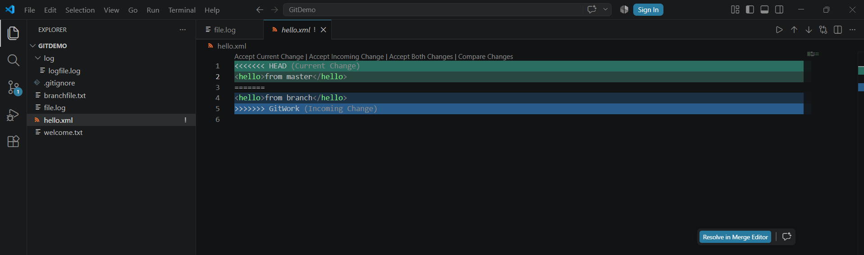
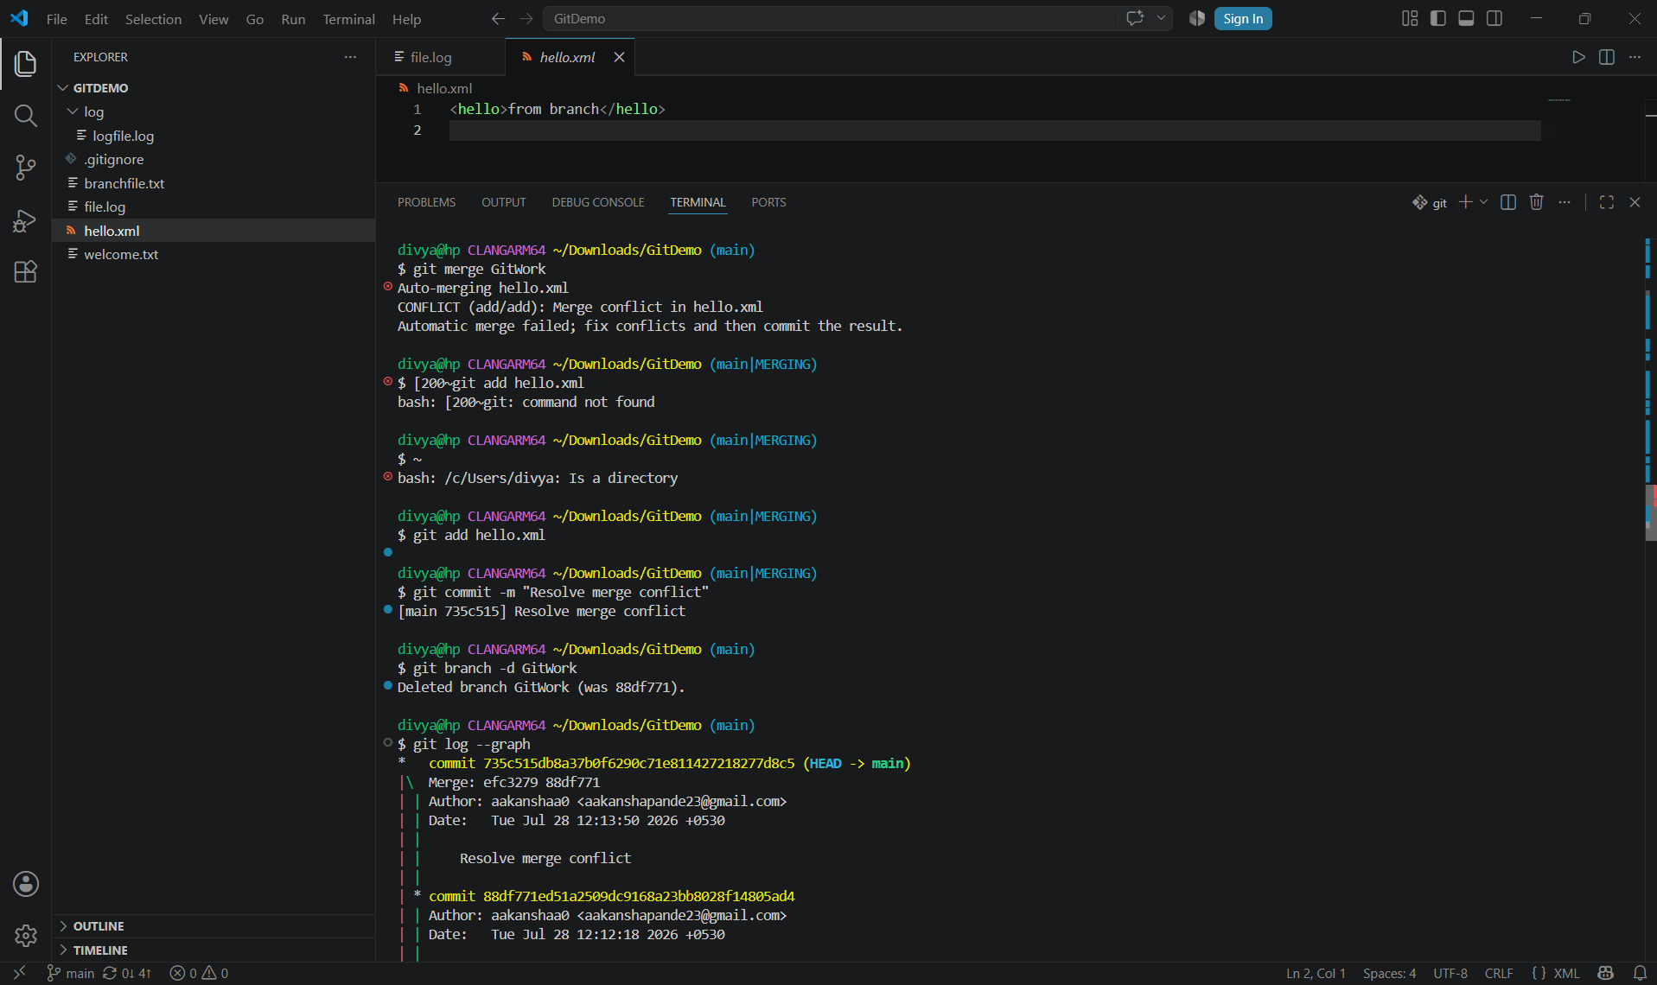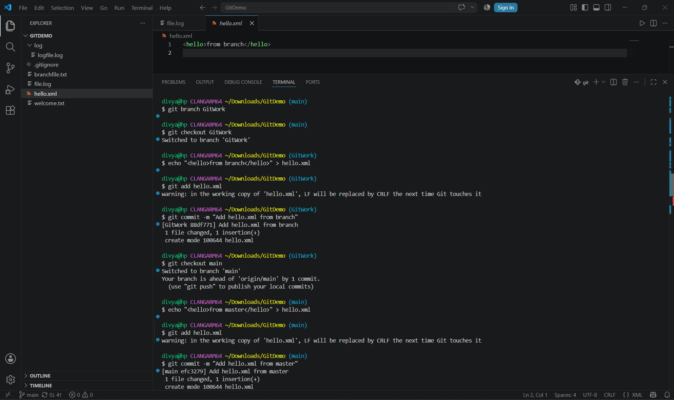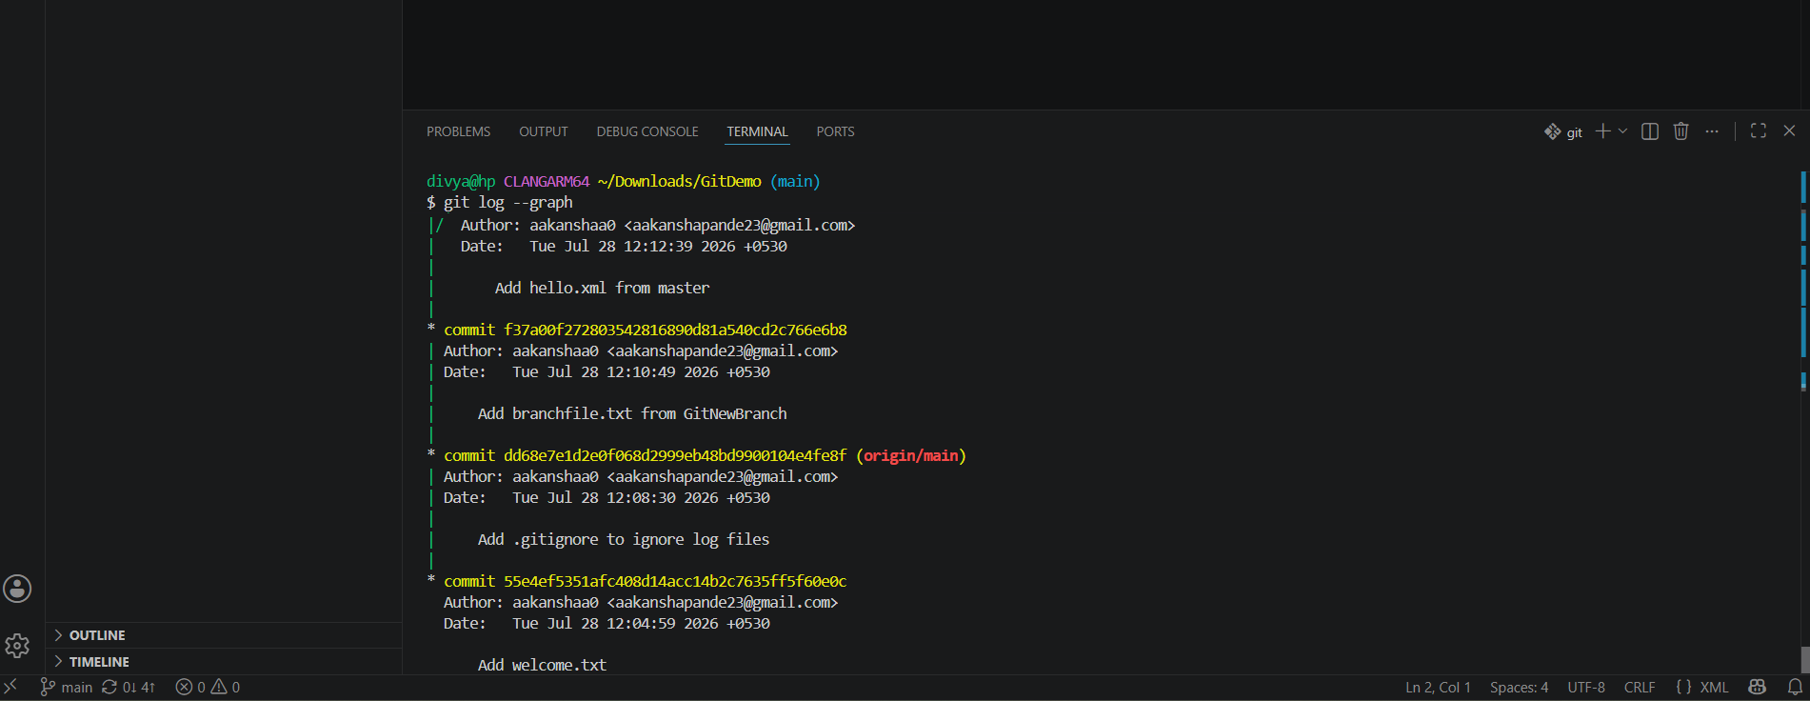
Output: Conflict resolved and merge completed successfully.

Assignment 5: Clean Up and Push
Aim: Verify clean state, pull latest changes, and push to remote.
Steps Performed:
1. Checked git status (clean state).
2. Listed all available branches.
3. Pulled latest changes from remote.
4. Pushed all changes to remote repository.
Commands Used:
git status
git branch -a
git pull origin main
git push origin main
Screenshot:
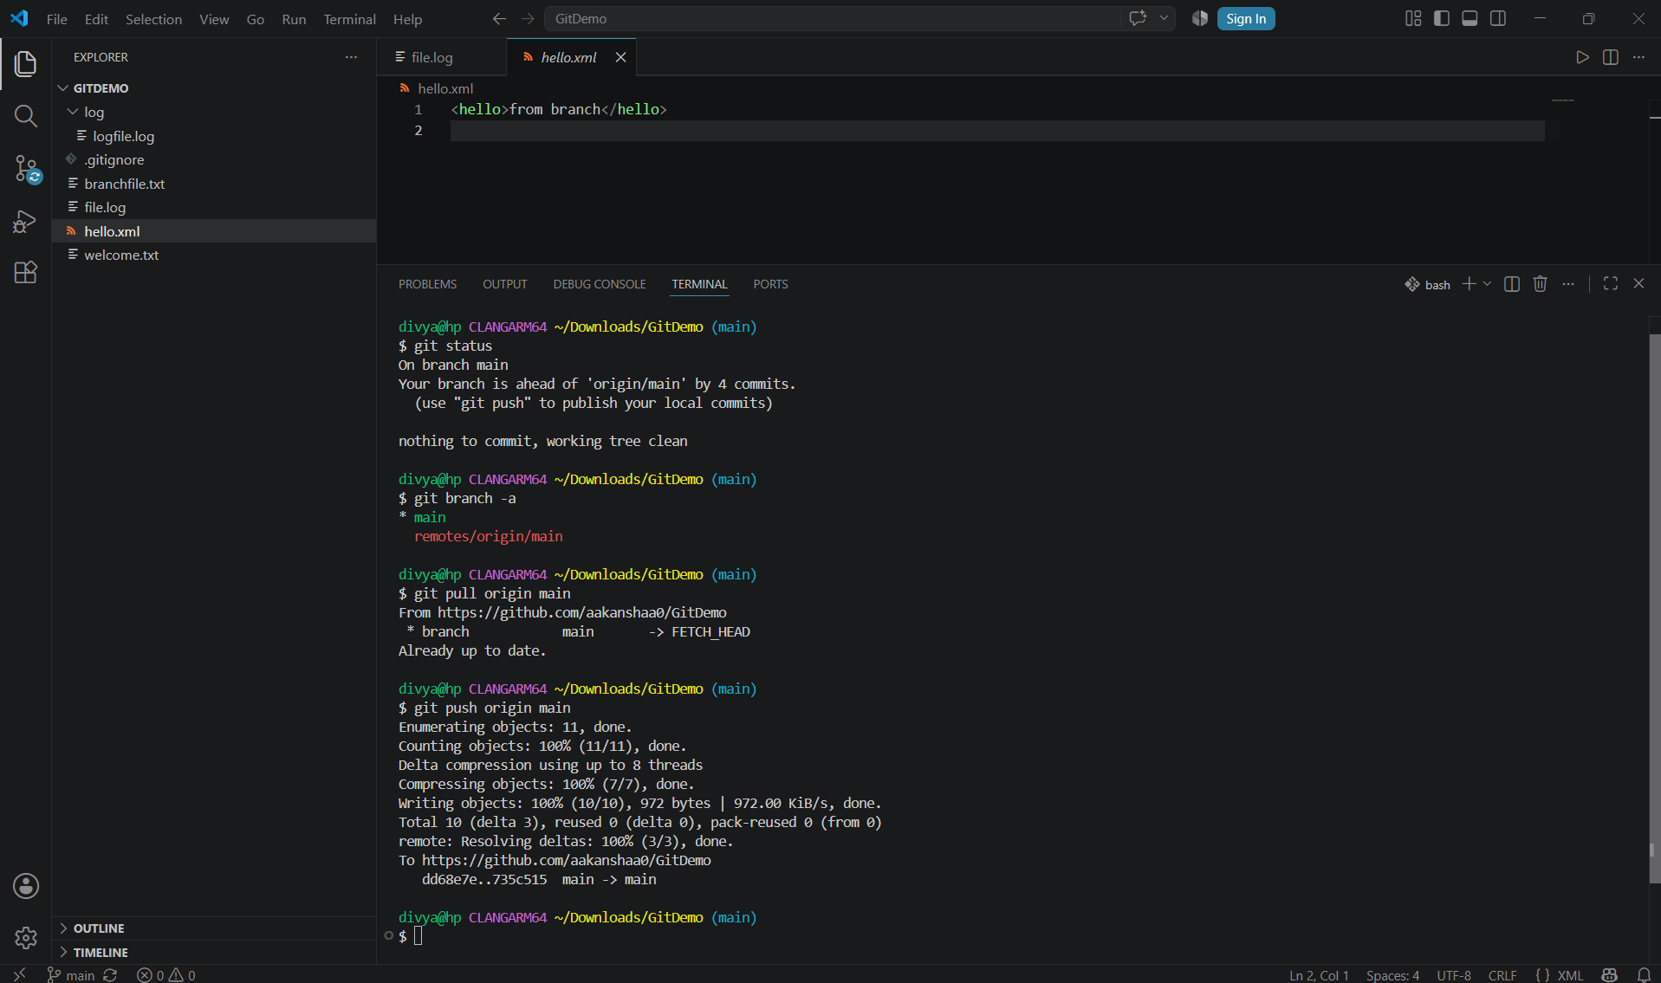
Output: All changes successfully pushed to remote repository.

